* pip list

The pip list command returns the list of packages in the current **environment**.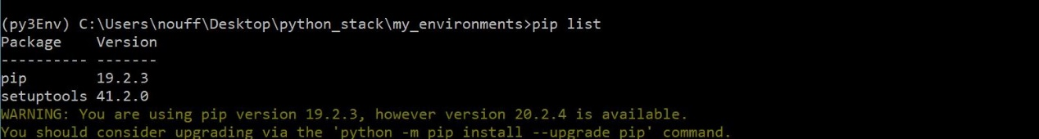

* deactivate (This will deactivate your virtual environment)

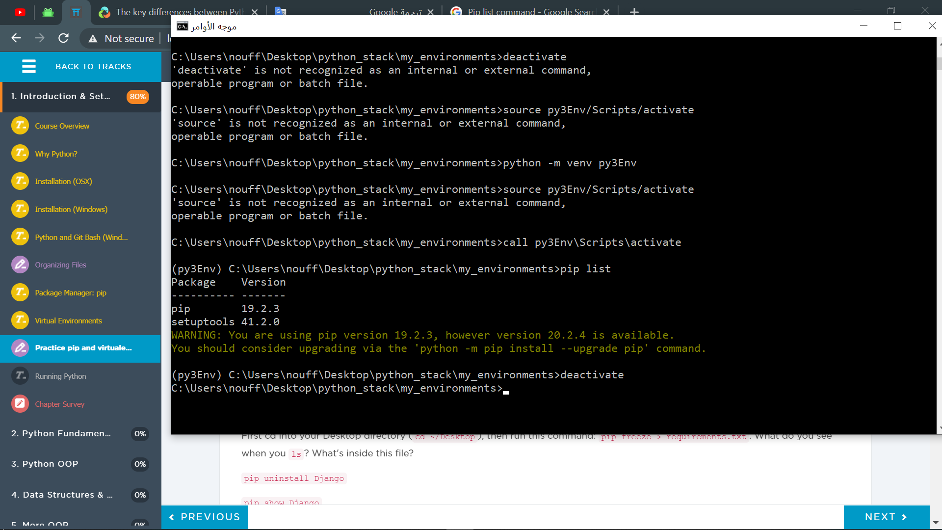

* pip3 list (How is the result different from when you ran pip list with the virtualenv activated? Hint, you should not have as many things listed when the virtualenv is deactivated. If your results are the same, go back and figure out what went wrong.)

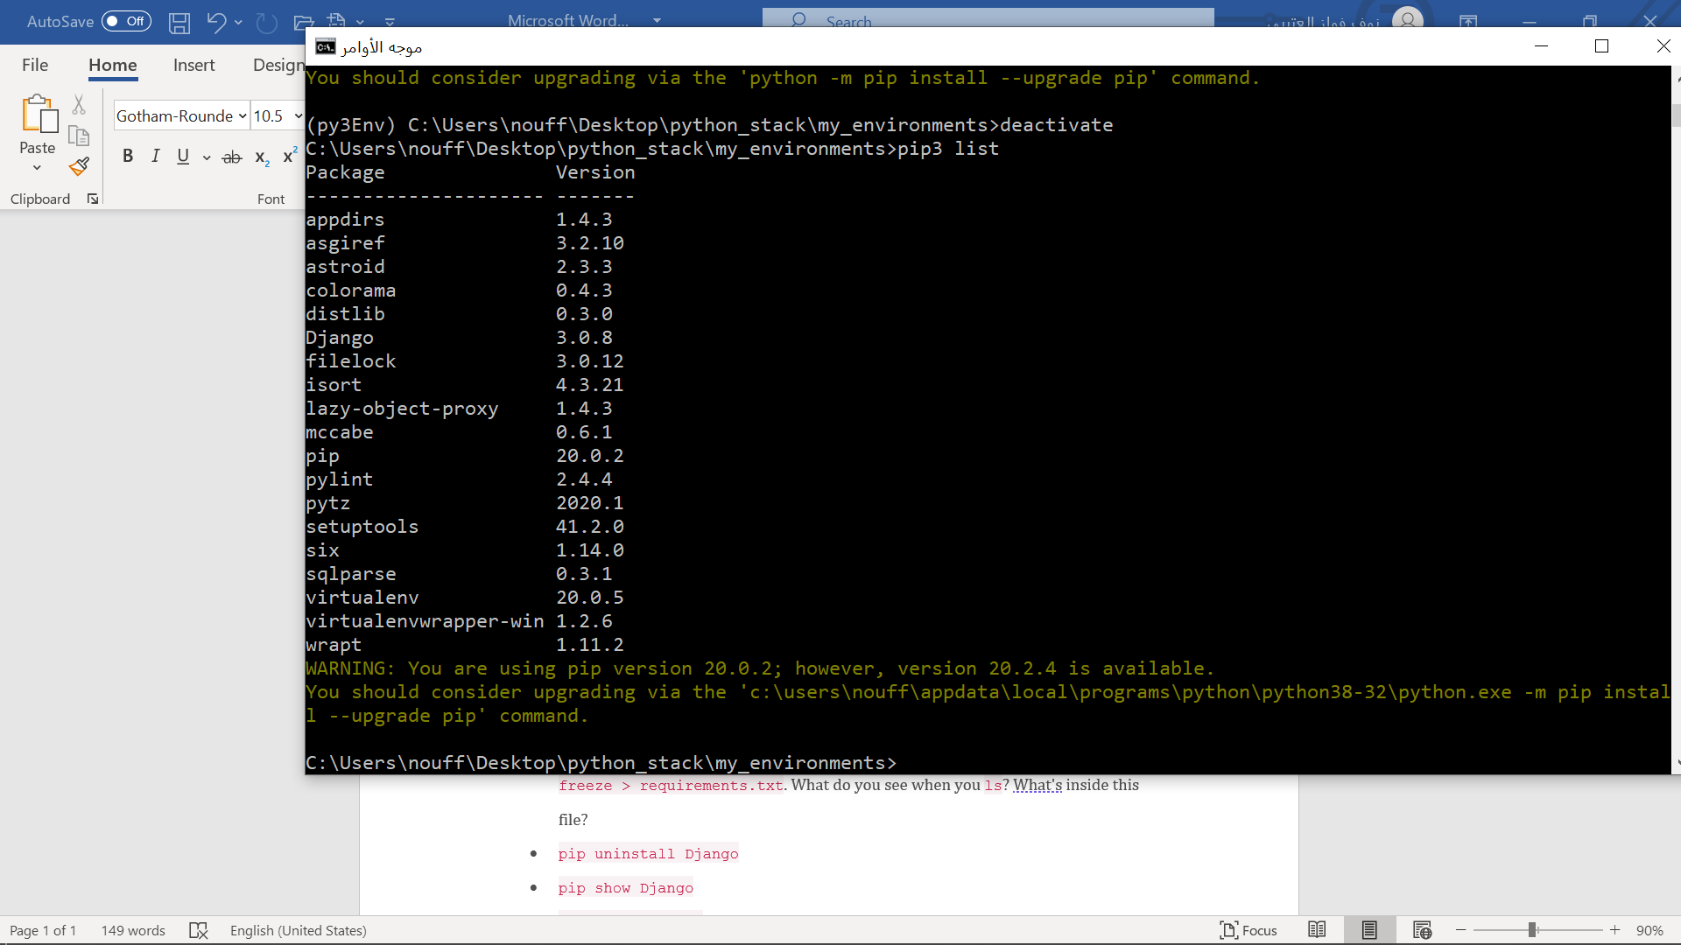

* source myEnvironments/py3Env/bin/activate (Adjust the path as needed to **re-activate the virtualenv**; for windows call myEnvironments/py3Env/Scripts/activate)

To reactivate the virtual Env

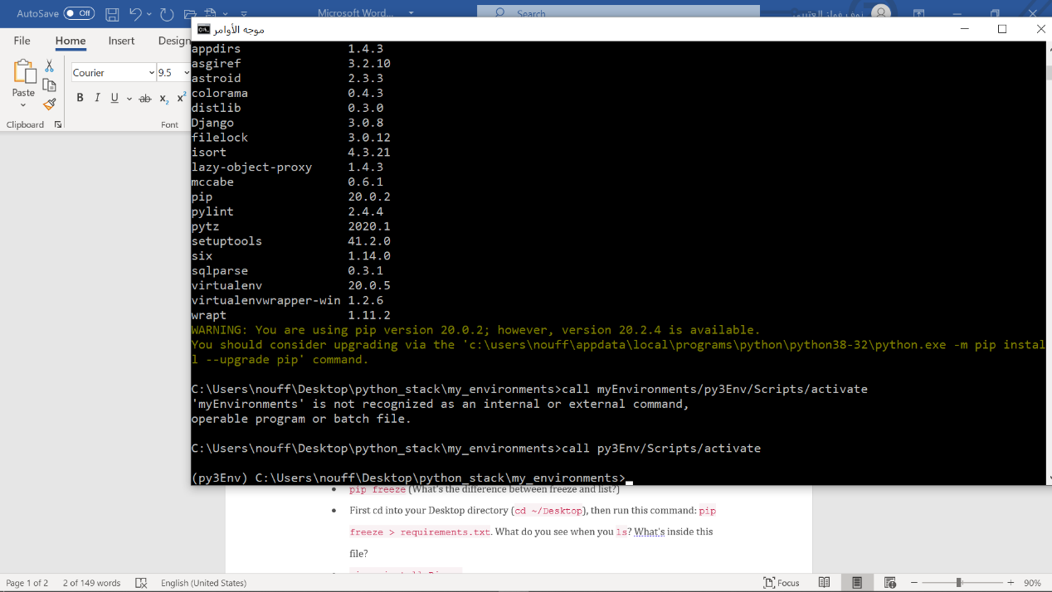

* 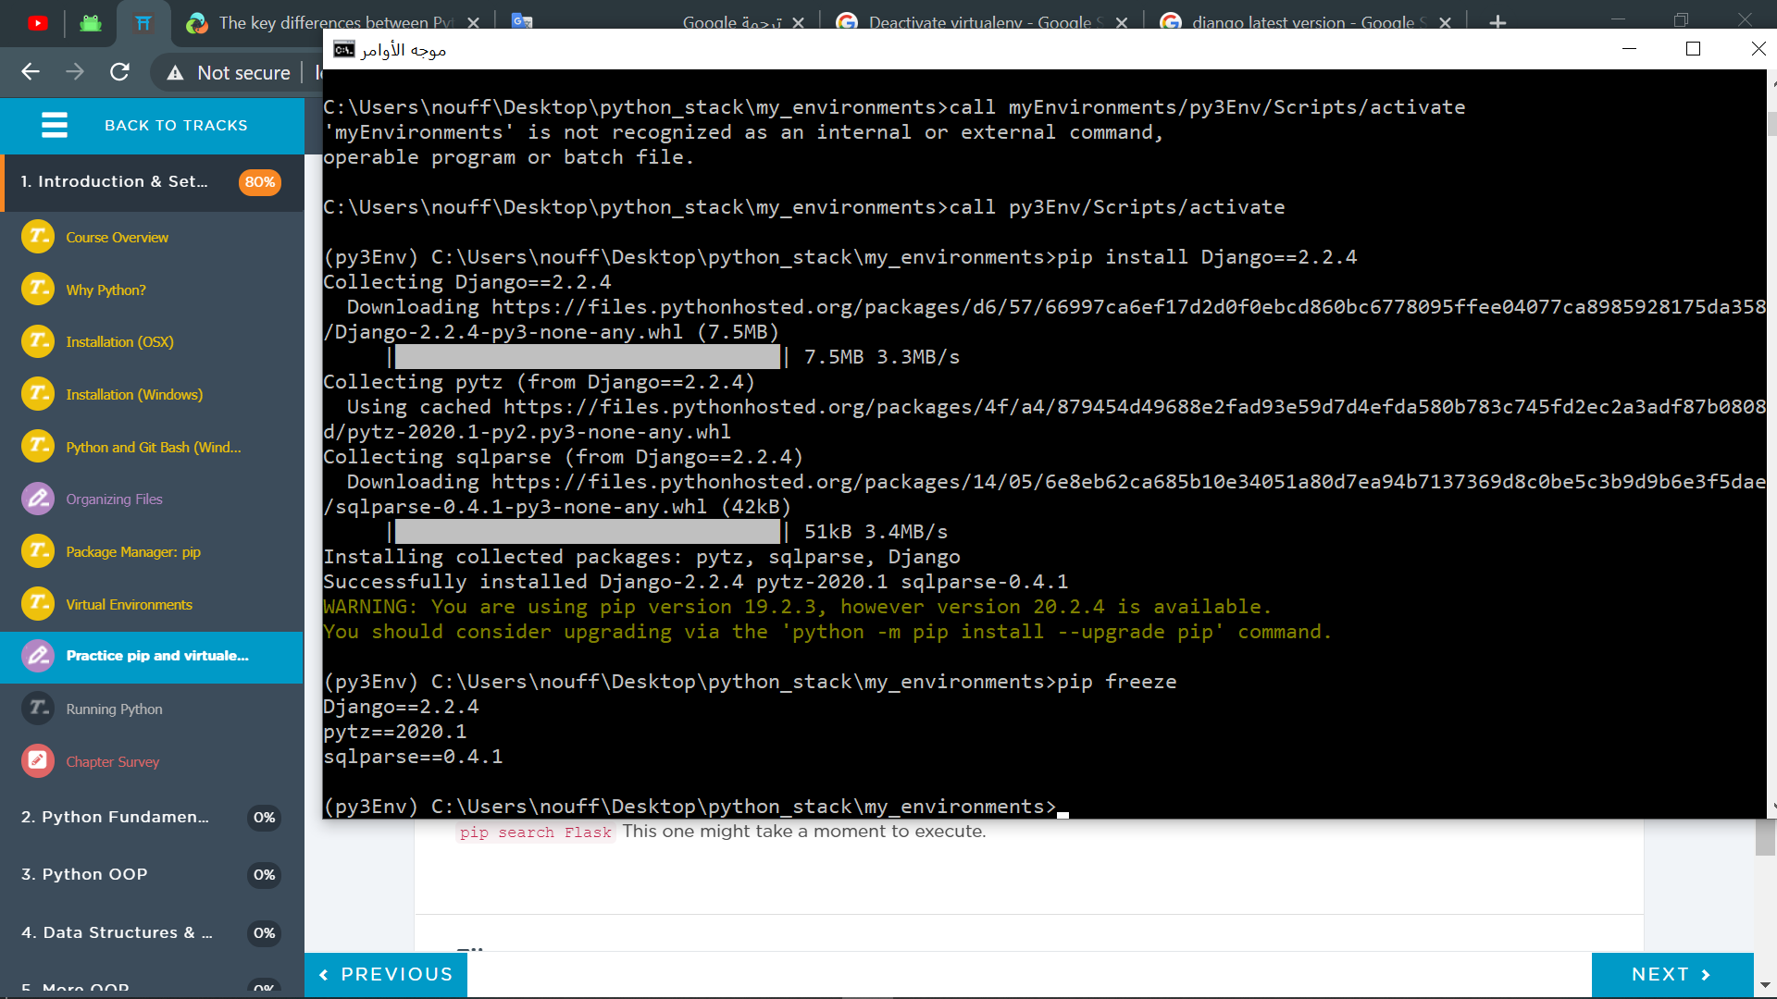pip install Django==2.2.4 (What information do you see returned in terminal after this command?)
* pip freeze (What's the difference between freeze and list?)

**pip list** shows ALL installed packages. **pip freeze** shows packages YOU installed via **pip**



* First cd into your Desktop directory (cd ~/Desktop), then run this command: pip freeze > requirements.txt. What do you see when you ls? What's inside this file?
* pip uninstall Django

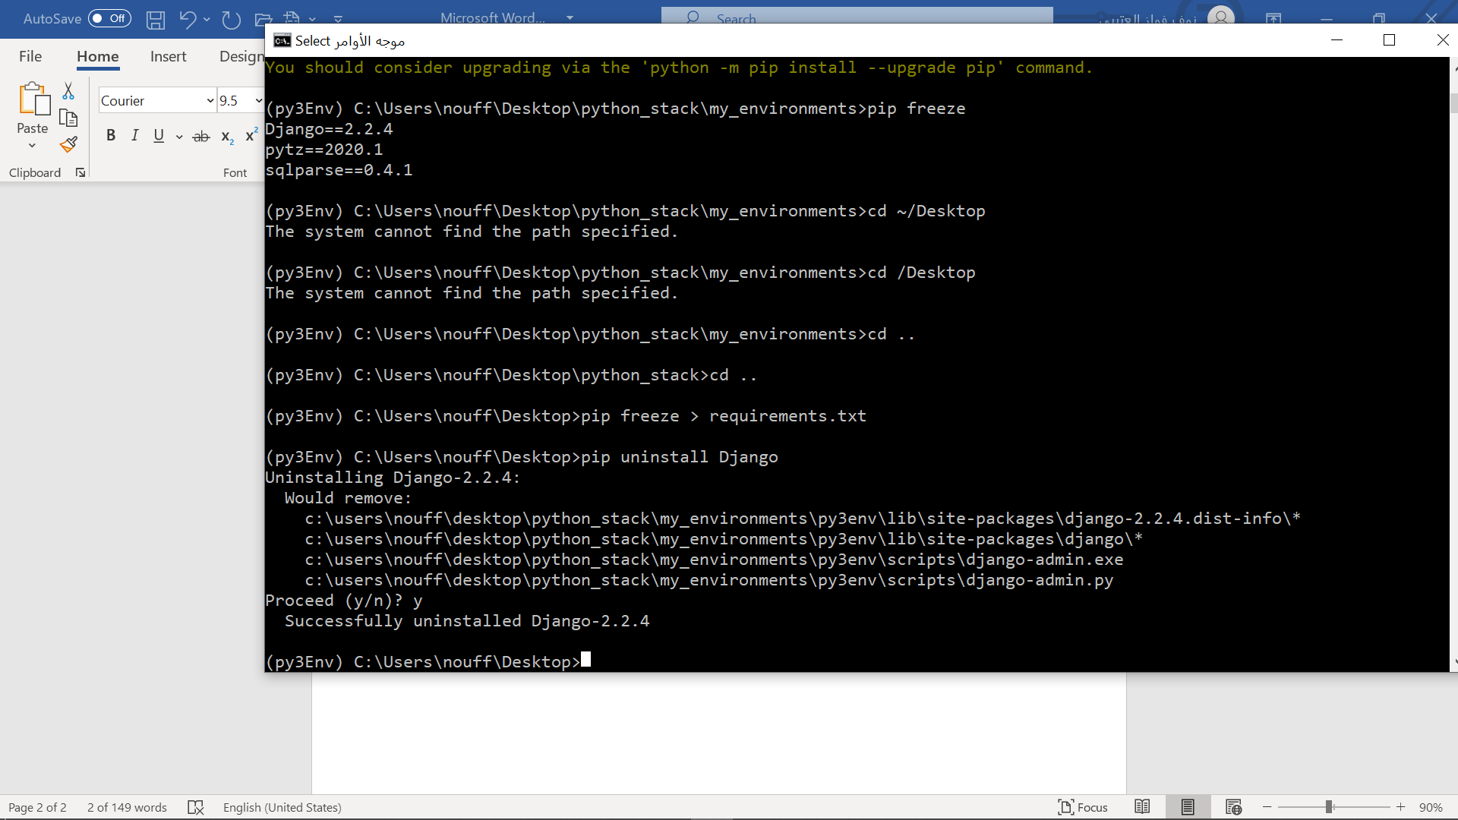

* pip show Django

To find the package version.

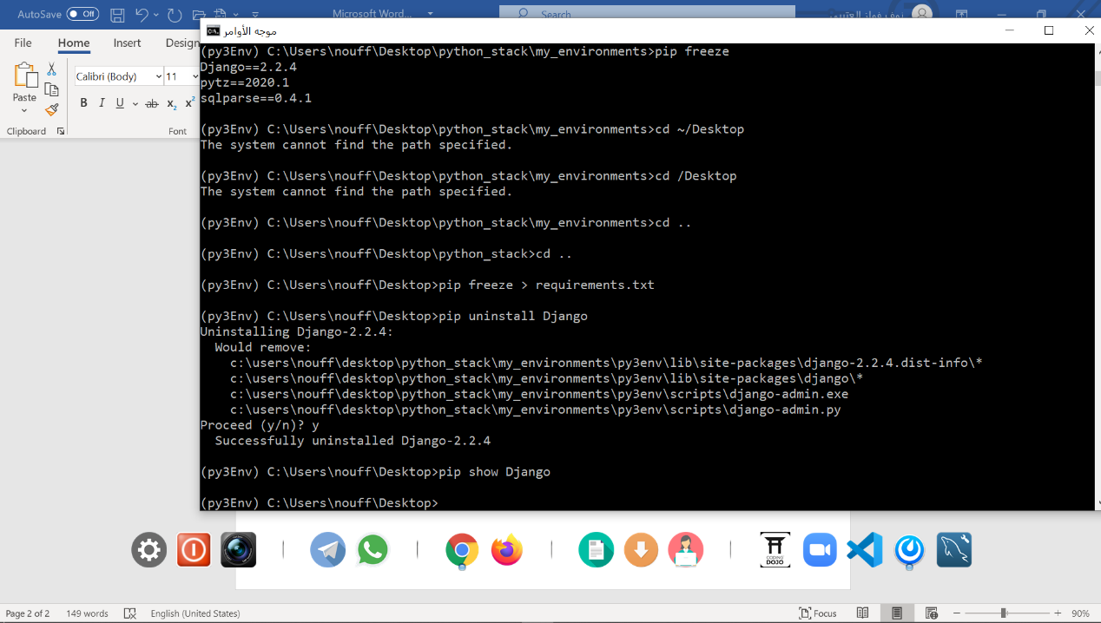

* pip search Flask This one might take a moment to execute.

**pip search** allows you to **search** PyPI for any package using the **pip search** <package> command. The result of the command returns the name and description of all the matching packages

